Robot assisted fracture reduction using path planning

Ajeet Wankhede1, Likhita Madiraju1, Kevin Cleary2, Reza Monfaredi2

1 Robotics Masters Program, A. James Clark School of Engineering,

University of Maryland, College Park, Maryland

2Sheikh Zayed Institute for Pediatric Surgical Innovation,

Children's National Health System, Washington, DC

ajeet@umd.edu1, likhita.madiraju@gmail.com1, rmonfare@cnmc.org2

***Abstract*****—** In bone fracture surgery surgeons are most concerned with the quality of surgical procedure including the usage of fluoroscopic imaging, reduction accuracy, and operation time. Robot assisted fracture reduction is believed to increase surgical operation quality and efficiency compared to manual reduction, for it has the capacity to provide high precision in alignment while reducing the usage of interoperative fluoroscopic imaging. We developed an automatic bone alignment algorithm for a surgical robot in fracture reduction surgery using bone X-ray images. The bone fragments are analyzed to create surface normal vectors, and cross product of the vectors is used as a cost function to guide the robot.

Keywords—bone fracture reduction, path planning, A* heuristic cost, heuristic based search algorithm

# Introduction

We propose a new heuristic function for alignment of bone fractures using path planning. We have incorporated the algorithm for wedge fractures, followed by other complex fractures and simulated the algorithm on MATLAB.

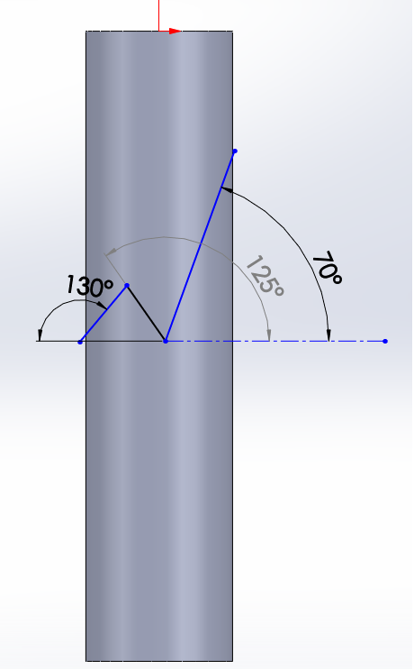

Figure 1 Bone fracture model with fracture angles – 2D view

# Plan Of Action

Based on CT images a 3D model of fractured bone is created. This helps to create a profile of surface of the fragments. A surgeon selects multiple points on the surface of each fragment. These points are automatically correlated with their mirror parts and then used for matching the surfaces. Surface normal at each of these points are found. Cross product of these surface normal with their mirror part, give us the amount of rotation required to align the fragments. The fragments are rotated until the cross product is found to be zero. This is the heuristic function used that drives the direction of search. While rotating the fragments, care has been taken to avoid the intersection of fragments. Once the fragments are aligned then the series of matrices defining the rotation is displayed as the optimal path.

# Method

As shown in figure 1, a simple bone fracture is modelled in Creo and .stl file is created. This model depicts a simple wedge fracture. The stl model is imported into MATLAB. This is show in figure 2. The top part is rotated with respect to bottom part to simulate a simple fracture. The top part is rotated by 5, 10, and 30 deg about X, Y, and Z axis. Also, the top part is translated by 70 units in Z direction.

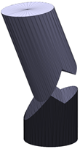

Z

Y

X

Figure 2 Bone fracture with rotation of part 1 with 5, 10, and 30 deg in X, Y, and Z axis respectively and translation of 70 units of part 1 in Z direction.

In-built functions in MATLAB are used for generating a mesh. Similarly, surface normal at center of each triangle is found. Surgeon selects multiple points on the surface as shown in figure 3 in big red arrows. Figure 3 shows generated mesh and selected normal of the fractured bone.

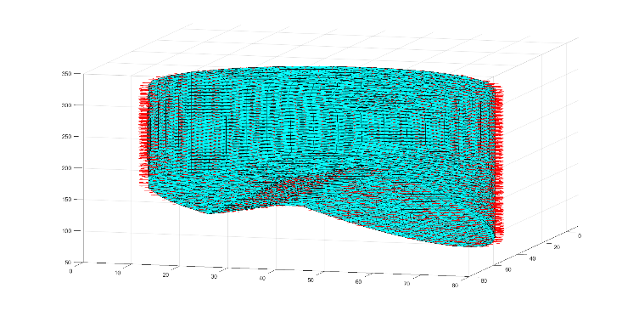

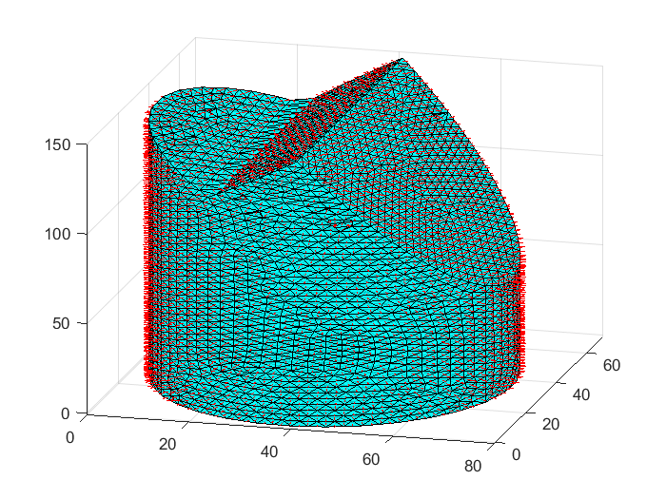

Figure 3 Diagram bone fracture with mesh and surface normal shown in red color

# A* Algorithm

The A* search Algorithm [5] is like other graph searching algorithms in that it can potentially search a huge area of the map quickly. Cross product of the selected normal is found. In our case as shown in figure 3, there are three cross products as we know which vector corresponds to which vector. The modulus of these three cross products is found and then added to find the cost. The value of cost is compared with minimum cost which is 0.01. If the cost is greater than the minimum cost, then bottom part is rotated by 0.1 deg. Six actions are taken for each node which comprise of rotation in clockwise and counter clockwise direction about X, Y, and Z axis. The new nodes are added to a queue along with their costs. The node with minimum cost is selected as current node for further expansion. If the cost is less than minimum cost, then the search is stopped. The optimal path is found by back tracing the parent nodes from goal to start. A list of rotation matrices giving the path for aligning the bone fragments is given by the optimal path.

# Conclusions

With the heuristic function, an optimal path can be found to align the bone fragments. Therefore, it enables the surgeon to plan the optimal rotation path in a better way, as he/she is restricted by the number of computations when done manually.

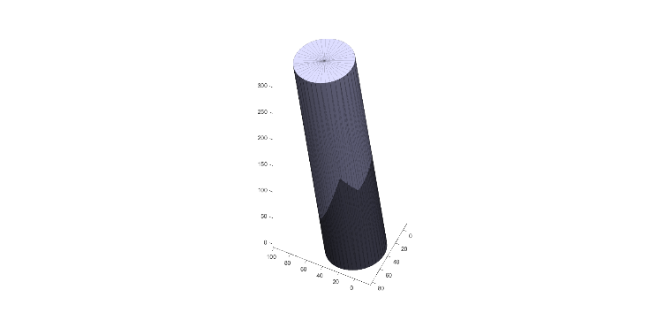

Figure 4 Bone fragments after alignment

# Future Work

We plan to implement various novel heuristic functions to improve the speed of alignment of the bone fragments. We will compare those different heuristic functions. We can increase the resolution further, to accurately detect collision between fragments while rotating. A collision avoidance module can be added by moving apart the fragments in opposite direction and then rotating them. Different collision detection methods can be implemented. In order to model the bone fracture accurately, we plan to do the quantitative analysis of MRI images to detect the surface from their boundaries or contours. This will further reduce the surgeon’s time as he/she would no longer need to feed the surface points to the algorithm as proposed in this paper. We would like to explore other path planning algorithms such as D*, RRT, RRT* to improve the search time.

##### References

1. Jan Buschbaum, Rainer Fremd, Tim Pohlemann, Alexander KristenY, “Computer-assisted fracture reduction: a new approach for repositioning femoral fractures and planning reduction paths” Int J CARS (2015) 10:149–159.
2. Eduardo M. Suero, Musa Citak, Nael Hawi, Emmanouil Liodakis, “Comparison of algorithms for automated femur fracture reduction” Int J Med Robotics Comput Assist Surg. 2018;14:e1864.
3. Shm’ichi Warisawa, Tatsuya Ishizuka, Mamoru Mitsuishi, “Development of a femur fracture reduction robot” Proceddings of the 2004 IEEE International Conference on Robotics & Automation.
4. Ruihua Ye, Yonghua Chen, “Path Planning for Robot Assisted Femur Shaft Fracture Reduction : A Preliminary Investigation” VECIMS 2009 – International Conference on Virtual Environments, Hong Kong, China